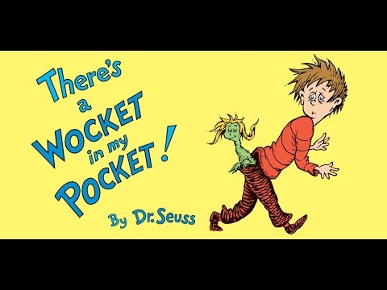

**Did you remember to empty your pockets, before placing in the hamper? Please empty all pockets prior to placing in the soiled linens!**



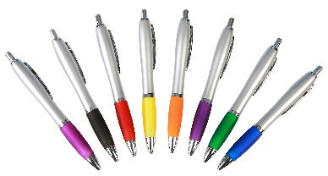****



Just one pen can ruin an entire load of scrubs with ink stains. One load contains approximately 500 pieces at a value of $3000. HCSA processes an estimated $70,000 worth of scrubs daily.

***Thank you!***

***HCSA***